Приложение 1

bag, back, dad, that, land, hand, track, carry, Pam, can, has, cat;
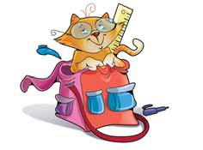

This is Pam. Pam has something in her bag. “Pam, come back,” Dad says. “What are you carrying in your bag?” “Nothing, Dad,” Pam says. Then Dad opens Pam’s bag. “What’s that, Pam?” Dad asks Pam. “It’s a cat, Dad,” Pam says. “Can we keep it, Dad? Please!” “Oh, alright,” says Dad and puts the cat down with his hand.

train, wait, great, late, safe, brave, Jake, say; This is Jake. Jake is waiting for the train. Jake likes to ride the train. Here comes the train. A crocodile is on the train. Is Jake safe? What do you say? Yes, Jake is safe. The crocodile likes to ride the train, too. Now Jake and the crocodile are riding the train together. That’s great!
