Приложение 2
Sport Crossword
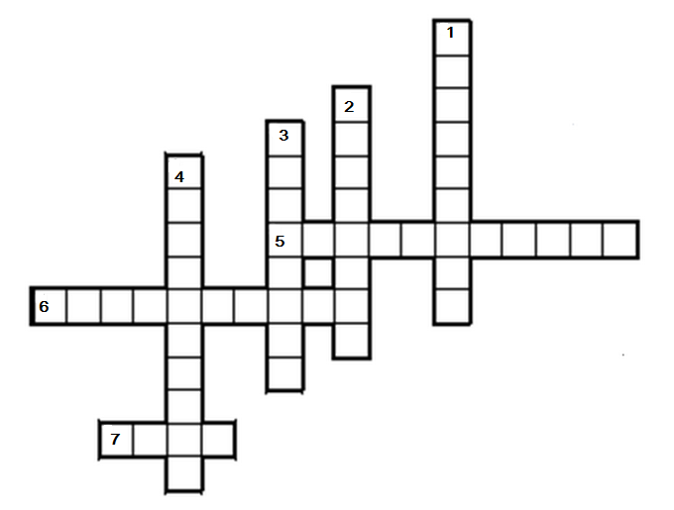
Down
1. b _ d _ n t _ n 2. b _ s _ b _ _ _
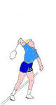 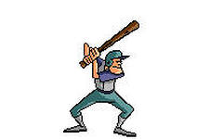
3. f _ _ t b _ l _ 4. v _ l _ e _ b _ l
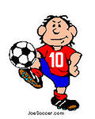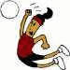
Across
5. t _ b _ e t _ n _ i _ 6. b _ s k _ t _ o _ _ 7. g _ l _
