**Приложение 3**

Match the words and the pictures

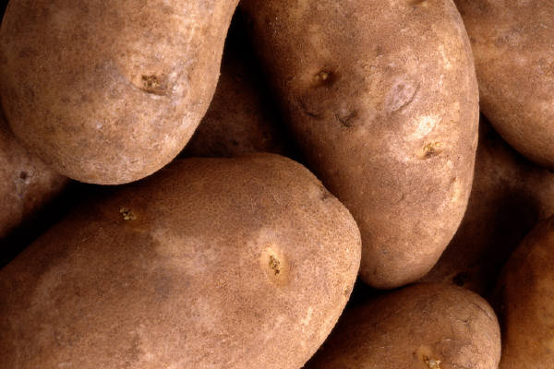 **to light sparkles C:\Users\Тимур\AppData\Local\Microsoft\Windows\Temporary Internet Files\Content.IE5\51YA0TL8\MC900298865[1].wmf a bonfire**

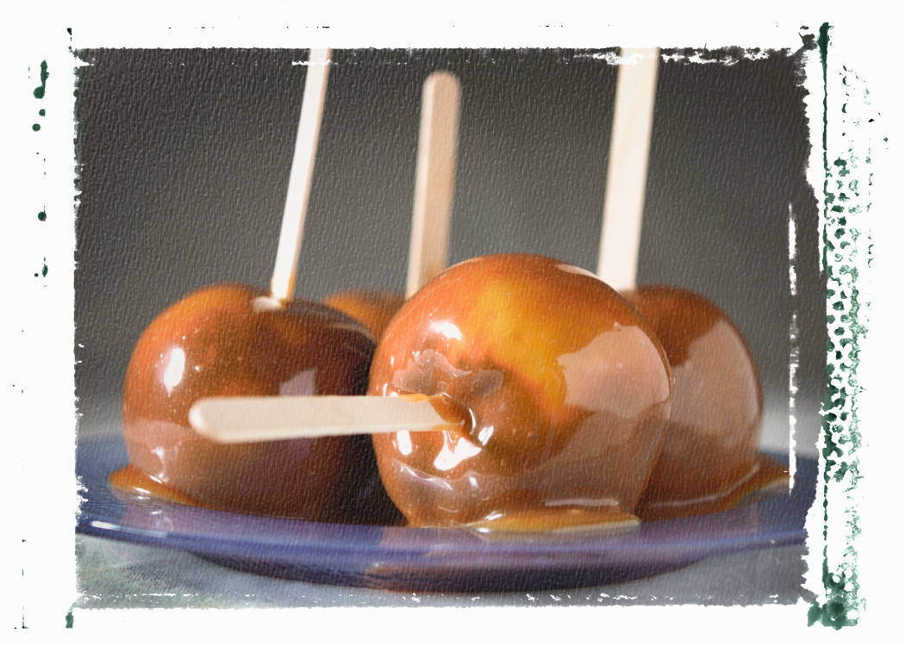 **hot dog C:\Users\Тимур\AppData\Local\Microsoft\Windows\Temporary Internet Files\Content.IE5\GWFSMQZL\MC900232962[1].wmf** **a guy**

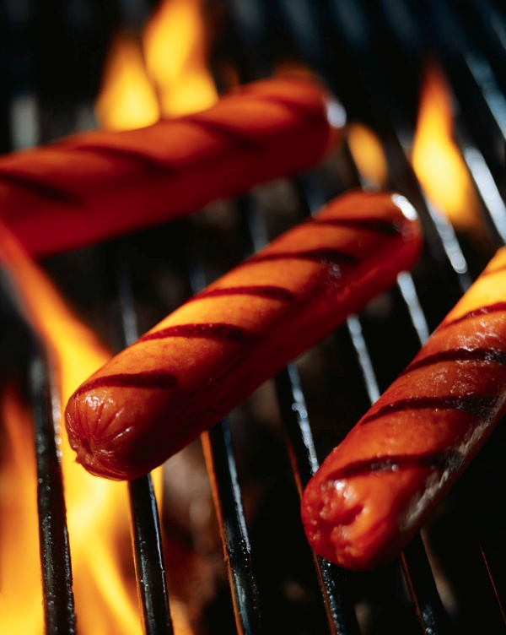 potatoes 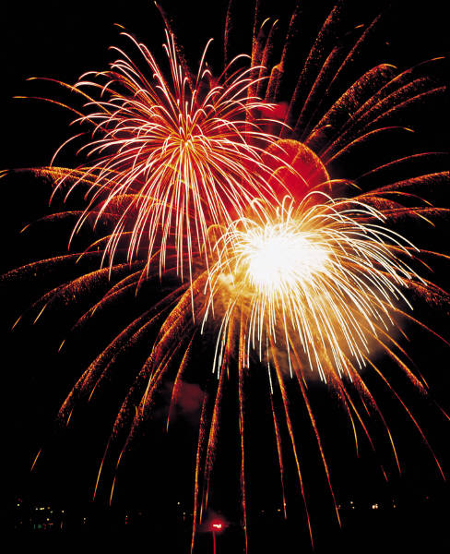fireworks

C:\Users\Тимур\AppData\Local\Microsoft\Windows\Temporary Internet Files\Content.IE5\Z3E1TJ47\MC900183706[1].wmf **toffee apples** C:\Users\Тимур\AppData\Local\Microsoft\Windows\Temporary Internet Files\Content.IE5\51YA0TL8\MC900410647[1].wmf **sparkles**

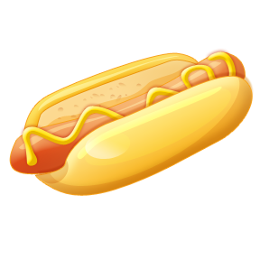 **sausages**  C:\Users\Тимур\AppData\Local\Microsoft\Windows\Temporary Internet Files\Content.IE5\Z3E1TJ47\MC900232816[1].wmf **a scarf**