Moscow Suvorov military school

Children of the First world war
Project

Project manager:
English Teacher Nataliya Onikiychuk

Москва
2014

Aims:
1.Survey and study of little-known facts involving children in World War I.
2.Survey and study of their frontline merits and motives that led the children to the front.
3.Patriotic education of the suvorovites on the feat of arms of children – the participants of the First World War.
4.Education of pride and the sense of belonging to the history of the Fatherland
5.“The Army Children of the First World War” project aims to:
Objectives:
Subjective
To develop language, learning, cognitive and socio-cultural competence and compensatory competence.
Intersubjective
To facilitate the integration of academic and educational work.
Personal
To motivate cadets to learn by doing the research work.
- To help the suvorovites understand the affection of the hostility and war on children of that period.
- To highlight the important facet of the First World War as viewed from the social-historical perspective.
- To highlight the human cost of those in the front, and enrich the suvorovites’ historical knowledge;
- To provide a rich source of information for class discussion.
- To encourage the suvorovites’ interest in the history of Russia, to enrich and deepen their knowledge on the subject.
- ”The army children of the First World War” project, enables the suvorovites to understand the impact of the Great War on the society today.
- To investigate, analyze and learn about children during the First Word War.
- To produce a presentation and a short film in the target language (in English).
People are all connected to the First World War, either through their own family history, or because of its long-term impact on society and the world we live in today.
The years 2014–2018 mark the Centenary of the First World War, a landmark anniversary for Russia and the world. The First World War Centenary Partnership, led by IWM, is a growing network of more than 1,400 local, regional, national and international cultural and educational organisations who together will be presenting a vibrant programme of cultural events and activities, and digital platforms, which will enable millions of people across the world to discover more about life in the First World War.
Project Overview
Purpose.
To investigate, analyze and learn teenagers during the First Word War.
To produce a presentation and a short film in the target language (in English).
Stages of work:
Step 1-Motivation-November 2013.
Step 2 - Registration: November 2013
Stage 3-Decision making : December 2013.
Step 4 - Formation of working groups: December 2013.
Step 5 - Collection and processing of information: December-January 2014.
Step 6 - Discussion of collected materials: January-February 2014.
Step 7 - Making the project January-February 2014.
Step 8 - Discussion and Conclusion: March - April 2014.
Activities:
1. Survey of the materials about the history of World War I.
2.Creative work. The involvement of suvorovites in creative activity
and in the development of their creative abilities.
3.Survey. The destiny of children of the First World War.
4.The aesthetic and artistic education in the course of the project work

Process.
Step-by-step the suvorovites selected their topic, wrote the main idea, the outline and finally went through a cycle of writing drafts of their work on the project.
During the term the team made a planning and discuss planning and progress with the teacher.
During the term their work and all documents collected by the suvorovites were presented in class.
Project Scope
Students.
Students are12-14 year old teenagers and are at an elementary English level. They worked in teams of 3-4. Class size did not exceed 10 students (3 teams) in order to have enough teacher-team talking time.
Teacher.
The project can be run with one teacher.
I have had the pleasure of working together with suvorovites. The foreign teacher has always been busy discussing the progress with individual teams and especially when lower level suvorovites have a problem understanding instructions or comments in English.
Topic. The suvorovites have produce a 5-10 minute short film on the topic “Children during the First word war”.
Language. Suvorovites study English and all products are delivered in English. The suvorovites may still use their first language in team discussions although they are encouraged to speak English.
Homework policy. The teams could not recruit other students to do the work for them. The teams had worked diligently on the project.
Project Planning
This short project was set up for one term, so a total of around 10 hours of class time.
Preparation and finalising take around 8 weeks respectively.
This planning was a guideline, and some flexibility was required.
Classes got cancelled, teams didn't always finish their work on time, and re-scheduling tasks once in a while didn’t do any harm.
An overview of the tasks, duration, sequence and dependencies were provided in this Project planning.

To prepare the Project.
Select the classroom.
The ideal project classroom has groups of tables. There is a projector and the teacher computer. Each team had an access to 1-2 computers with the same software during the lessons.
The suvorovites usually studied in the language lab but when working with resources the library reference room was a good location. They also used seminar rooms for the presentations.
Arrange equipment.
A digital camera was required to make pictures for class presentation.
Not all teams had access to their own camera, so the teacher’s camera was available.
Suvorovites used a video camera.
Allocate personnel.
The suvorovites required the teacher for computer support during the lessons, and to lead the record and edit the film.
Prepare the handouts.
Prepare and copy a course syllabus and a set of progress reports for the students.

Lesson 1 Start Up Project
- To introduce project.
Teacher introduces project, distributes syllabus.
- To select team.
Suvorovites selected their teams of 3-4 members and sit down together.
- To select topic. They wrote the main idea.
The teams brainstormed. They had 2 lessons to make their decision.
Lesson 2
To write a progress report.
The suvorovites discussed their progress and planning. The teams planned their work, and discussed the report with their teacher in English.

Lesson 3.

To select the topic.
The teams made a final decision on their main idea of the project.
Teams planned their work and discussed the report with their teacher in English. The teacher approved the topic and the main idea.
To write the outline.
The teacher instructed the suvorovites on where to find the sources of information and how to collect the information.
Lesson 4-5.
The wok with the resources. The teams had 2 lessons to work with the documents, printed resources and to analyse the information.
Lesson6.
To present the visual aids.
Class discussion of the use of the PowerPoint program.
During the First World War, an enormous number of children became ‘temporary’ army children when their civilian fathers joined the Army as volunteers or conscripts. A significant proportion of Russian families today will count such children among their ancestors.
It is important to tell our children about the children of the First world war to provide a deep understanding of what they went through.
Lesson 7
Visiting of the exhibition devoted to the Word war I.

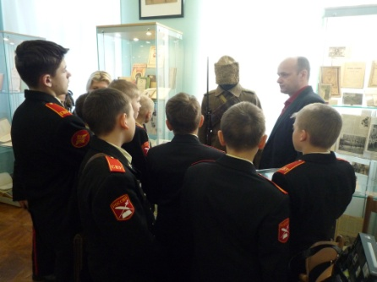
Lesson 8
Watching of the documentary film "Before the war I was a little boy".
On January 29 as part of the exhibition "Russia – for host" the RUSSIAN STATE ART LIBRARY hosted screening of the documentary film "Before the war I was a little boy".
Watching of the documentary film "Before the war I was a little boy".
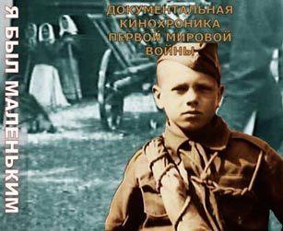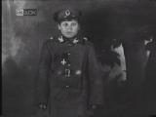
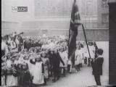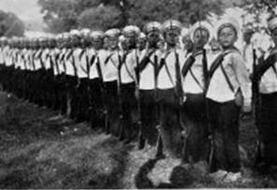
“Before the war, I was a little boy”.
Genre: War
Duration: 00:19:48
Director: Anna Bulgakov, Denis Fedorin
The film is about the children, the participants of the First world war and the tender age of romanticism, when the war was an extension of the game, when teenagers wanted to emulate their favourite heroes and when the heart ached because of the thirst for adventure and feats and when they were not afraid to die for " Faith, the Tsar and the Fatherland."
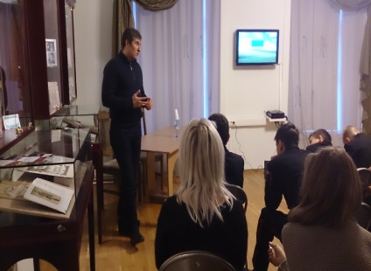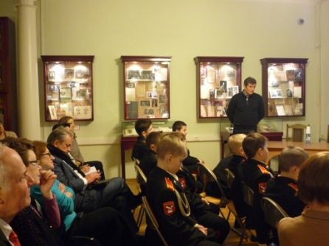
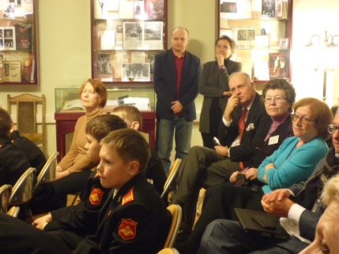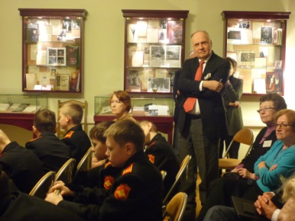
Since time immemorial, children took an active part in the wars and battles, helping adults.
During the First world war, children's patriotism covered all sectors of society, all institutions of the state. Pupils of schools, seminaries, high schools, military schools have asked their leaders to let them go to fight the enemy.
To help their fathers and brothers to defend their Fatherland, younger brothers aged from 7 to 13 years were eager to go to the front.
Children from Moscow, St. Petersburg, Odessa, Kiev, Yekaterinburg, Novgorod and many other towns and villages ran to the front. They fled singly or in groups. Only in September 1914 in Pskov gendarmes took from the trains more than 100 children going to the front.
The papers published that every day children ran away to the war.
A lot of officers did not want to take responsibility for the young defenders of the Fatherland. But if the children did get into a military unit , they performed their duties flawlessly. They brought bullets, collected cartridges and carried the wounded from the battlefield, took part in reconnaissance and sabotage operations.
We can not look into the future , but we have an opportunity to look back into the past to know how children lived in 1914.
Initially it was like an epidemic. Every children’s room had been turned into an arsenal. These notes about the children flashed in daily newspapers:" Vilna. The son of Colonel Rubanovich, the realist of the fifth grade and the son of a local police officer fled to the war”.
“Serpukhov. The 8 year old son of a nobleman V. Fredericks and his friend Kurdukov fled to the war”.
"Moscow. Vasilevsky asked to report if they had seen his missing 9 year old son Ivan."
"Parents of a 10 year old boy Shura beg him to return. Mom got sick”. "Oh , Lord God , get me my Vanya back."
Gymnasiums, realists and peasant boys fled to the war.
Some of them survived and continued to fight with adults, others had found eternal peace on the battlefield. They were awarded the George Cross for their feat of arms. The girls used to flee to the war too. In some cases, children's thirst for heroism was so great that many of the young fugitives returned under the parental roof, made new attempts to escape.
Books, pamphlets, newspapers, magazines were filled with photographs of young patriots. Games in schools took military content.
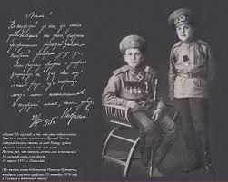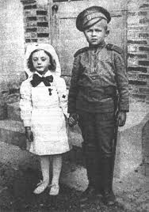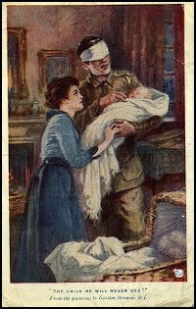
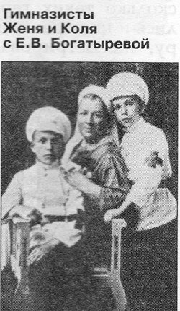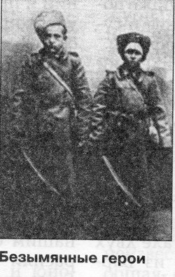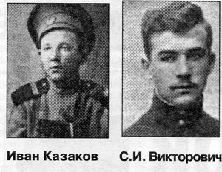
Cossack Ivan Kazakov aged fifteen recaptured a gun in the battle with the German troops. Later he saved his friend’s life and repeatedly successfully participated in battle reconnaissance. He was awarded three St. George St. George's Crosses, three medals and he also received the title of non-commissioned officer.
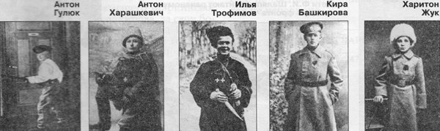
Famous Russian People who fled to the war when they were teenagers.
Future Marshal of the Soviet Union Rodion Malinovsky fought in the Russian expeditionary corps in France. At the age of sixteen, he was already an experienced machinegunner.
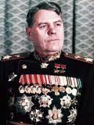

Works by Chukovsky about children of World war I in “Children and war”

(“ Niva” №52, 1915)
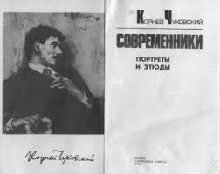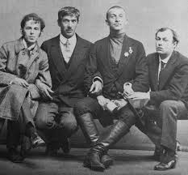
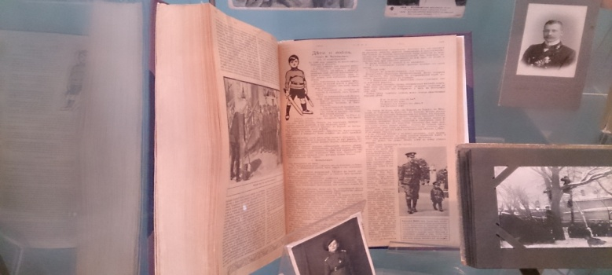
Valentin Petrovich Kataev (16 January1897–12 April 1986).
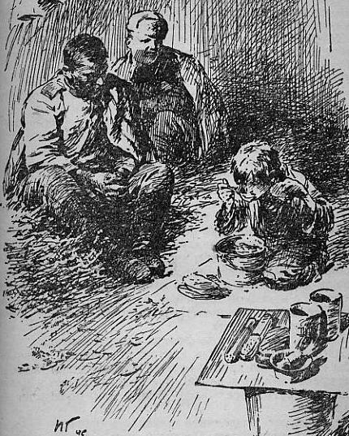
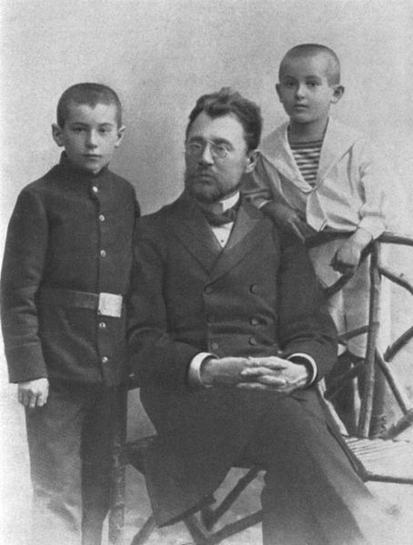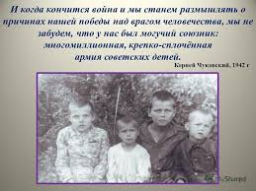
Pyotr Kataev with sons, Valentin & Yevgeni (1910)
Kataev was born in Odessa (then Russian Empire, now Ukraine) into the family of a teacher and began writing while he was still in gymnasia (high school). He did not finish the gimnaziya but volunteered for the army in 1915, serving in the artillery (Artillery Brigade). He was wounded, poisoned with phosgene, and he was awarded two George Crosses and the Order of St. Anne IV degree. Katayev began writing stories in 1916 during World war I. He served as a soldier at the front and it helped him to write his “Son of the regiment”.
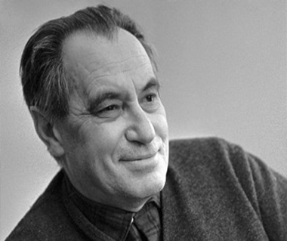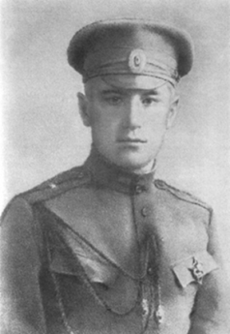
Valentin Petrovich Kataev (16 January1897–12 April 1986).

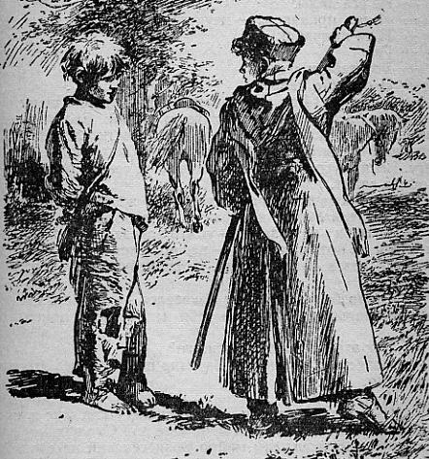
The suvorovites read “Son of the regiment” in English by Valentin Kataev.

Vsevolod Vitalievich Vishnevsky was a Soviet dramatist and prose writer.
He was born in 1900 in Saint Petersburg and educated at a Petersburg gymnasium. During World War I he enrolled in Baltic Fleet as sea cadet. During World War I he ran to the front. He was awarded the George Cross and two medals. Vsevolod Vitalievich participated in battles of the Russian Civil War as machinegunner in the1st Cavalry Army.Debut work: The First Horse Army.
Notable work: Optimistic Tragedy.
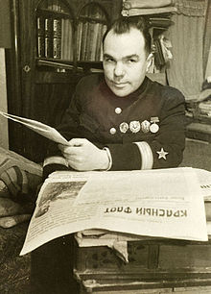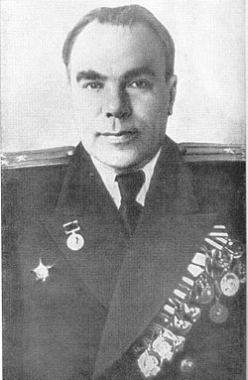
Ivan Aleksandrovich Pyryev was a Soviet-Russian film director and screenwriter.
At the end of 1915 Pyryev took one of the military trains and went to the front. He fought in the 32nd Siberian Regiment. He was wounded twice and was awarded the George Cross 3rd and 4th degrees.
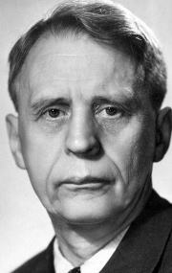
British children of the First world war.
The Army Children Archive.
"For the period of the war, many British children" temporarily "become" soldiers' children "when their fathers went to the front.
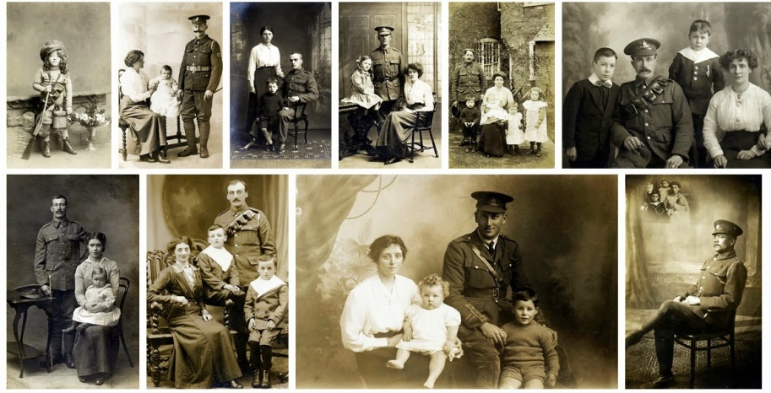
A Prayer For my dear Daddy
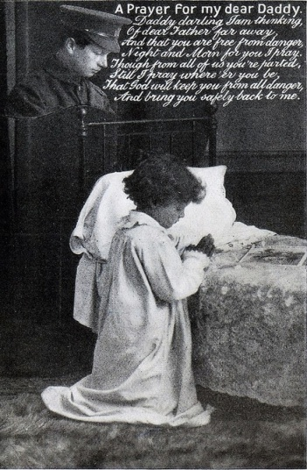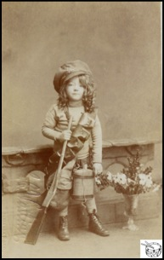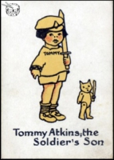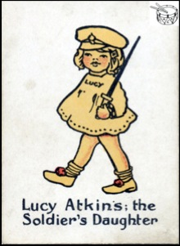
Lesson. To present the project progress.
All suvorovites helped prepare the presentation with Power Point.
The teams had 2 lessons to prepare the presentation.
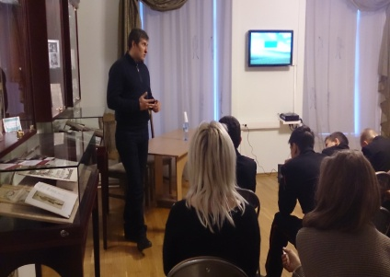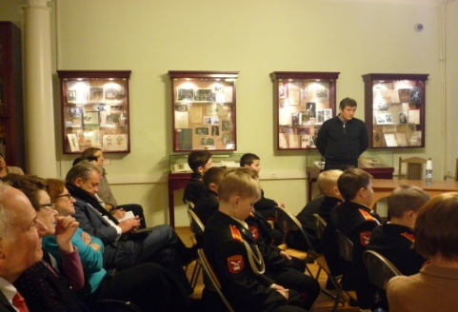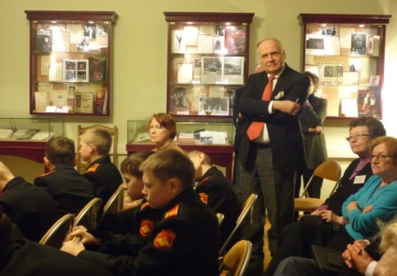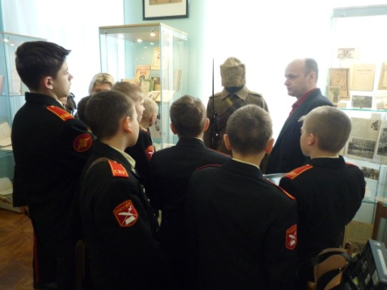
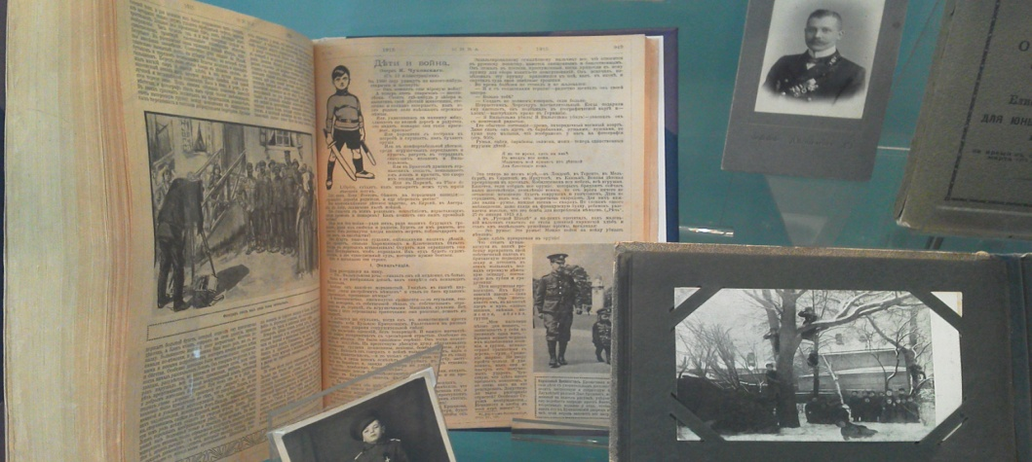
The story "Children and War“ (by Korney Chukovsky) was published in magazine "Niva» № 51(1915).
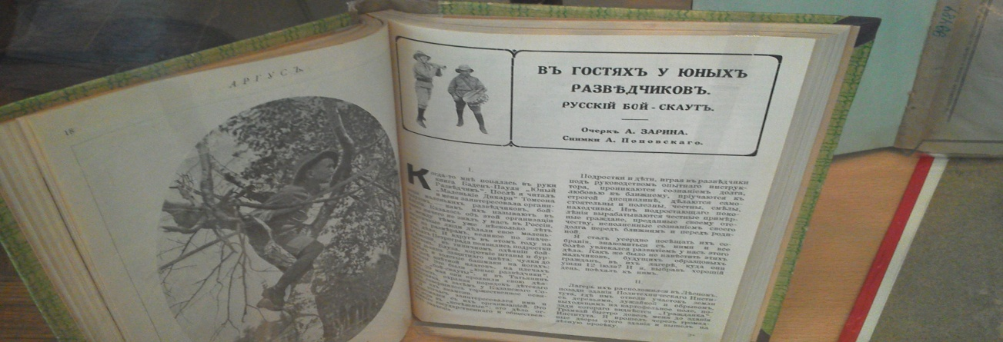
The Essay “Visiting young scouts.“ (by Alexander Zarina) was published in the journal" Argus ", 1916
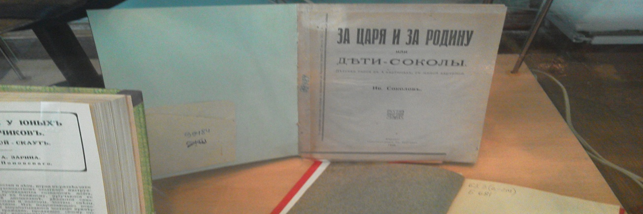
The play in four parts "Children- Falcons' (by Ivan Sokolov) 1916.
Meeting Denis Fedorin, the director of the film «Before the war I was a little boy » documentary( film).
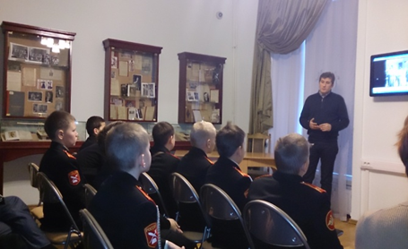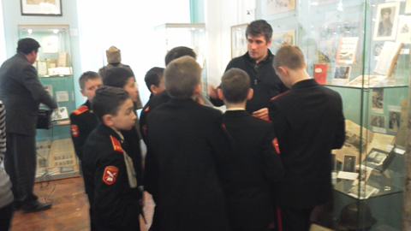
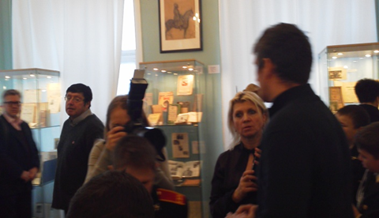
"Russia to hosts".Thematic exhibition in the Russian State Library of Arts. 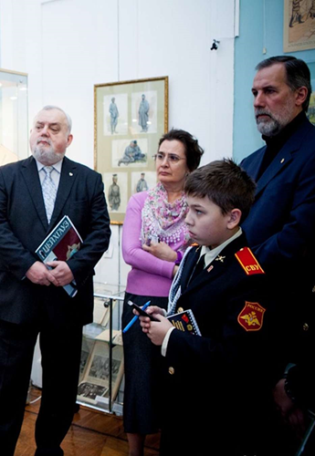 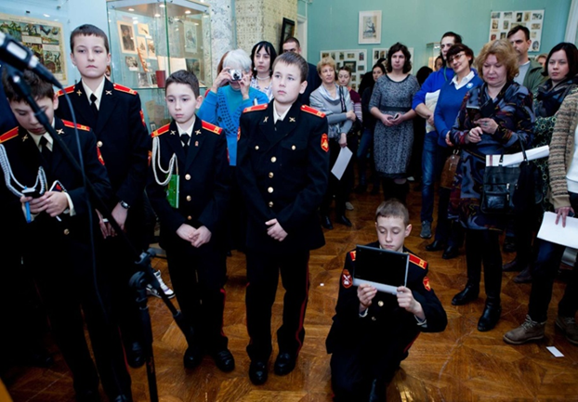
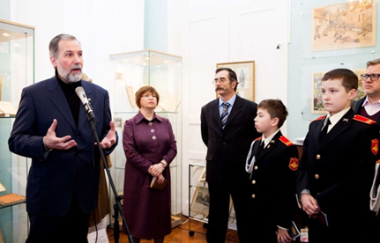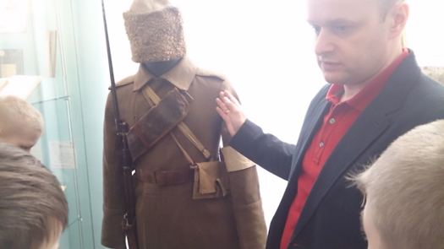
What is a project?
A project is an extensive task wherein all English skills, subject knowledge, higher level thinking skills and creativity are combined
What have the suvorovites learnt in a project?
In the project work the suvorovites have not only acquired language, but also improved their thinking skills, their creativity. They have also used new technology and increased their social skills and possibility to learn other subject knowledge.
The suvorovites have had a valuable and enjoyable English learning experience.

ABOUT ME
Having completed some English projects I am confident that project work is a valuable and fun way to practice and improve the suvorovites' language skills, thinking skills, social skills and creativity.
I have always wanted to share my experience and knowledge with my students.
I hope they have enjoyed the benefits of project work.
Information sources.
1.Eexhibits.
2.Photos, documents, documentary chronicles depicting children’ patriotism during the First world war.
3.The samples of the uniform and military equipments of soldiers of the First world war.
4. Printed editions of the period of the First world war. The story "Children and War“ by Korney Chukovsky, published in the magazine "Niva» ( № 51(1915).
5. The play in four parts "Children- Falcons”(by Ivan Sokolov) , published in 1916.
6. The story “Visiting young scouts“ (by Alexander Zarina), published in the
journal" Argus ", 1916.
6. Meeting Denis Fedorin, the director of the documentary film "Before the war I was a little boy."

