The Canterville Ghost

Episode 3 (Part 1)
- Listen and fill in the gaps.
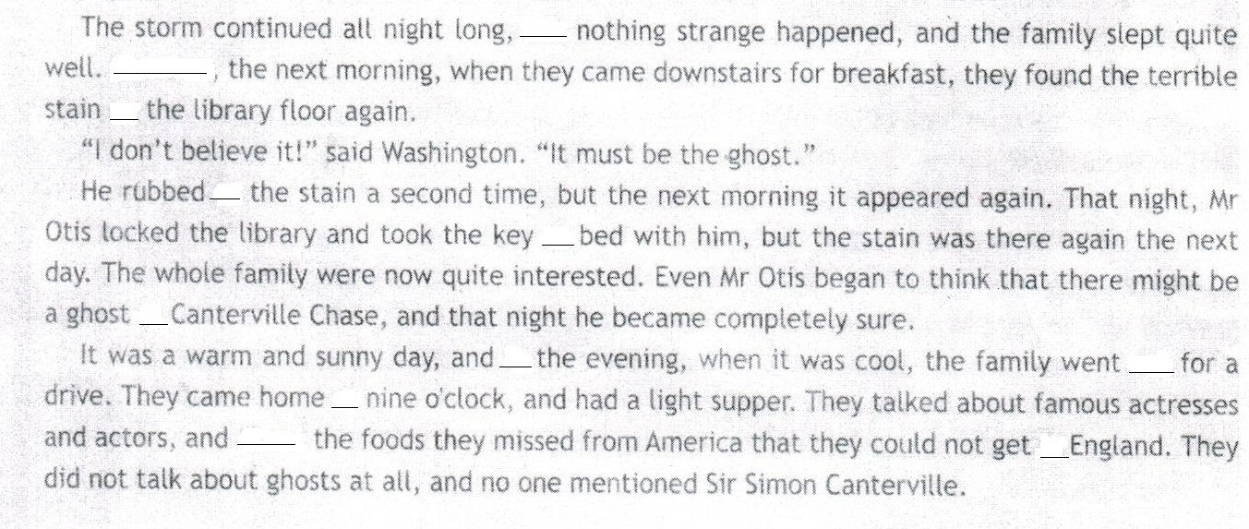
Episode 3 (Part 2)
- Choose the right word and fill in the gaps.

clank asleep oil calm torn wrists sight

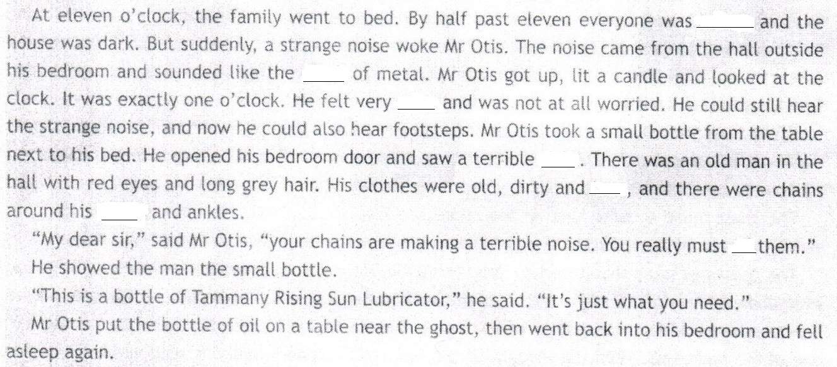

Episode 4
- Read clearly and with expression.

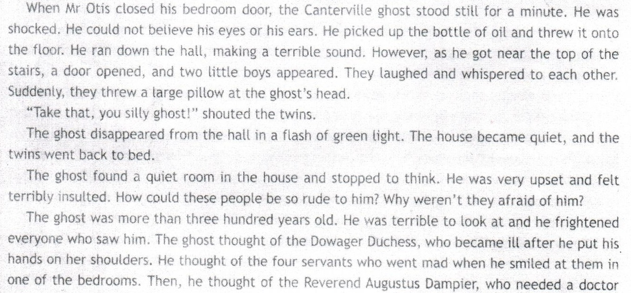

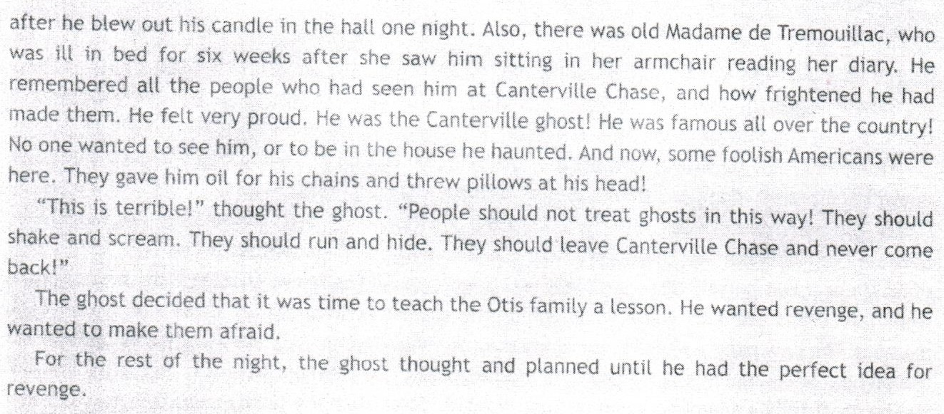

True or False

- The Ghost picked up the bottle of perfume and threw it onto the floor.
- There were twins on the top of the stairs.
- People in this house weren’t afraid of the ghost.
- The ghost was more than five hundred years ago.
- The Dowager Duchess went mad after the ghost put his hands on her shoulders.
- The ghost was very proud of the new hosts of the house.
- In the ghost’s opinion, people should shake and scream when they saw him.
- The Canterville Ghost wanted revenge.
- He didn’t have any idea last night.

