Keys («Ключи» для учителя)
1 .Прослушай отрывок и заполни пропуски
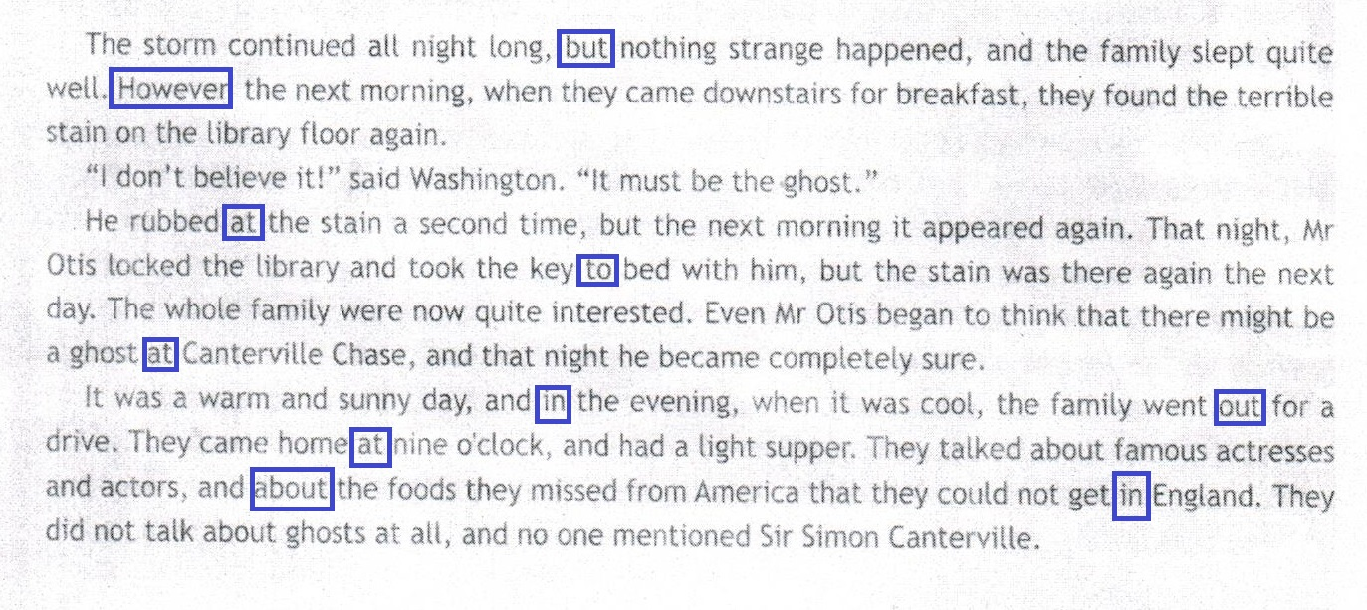

2. Прочитай текст и подставь слова в пропуски

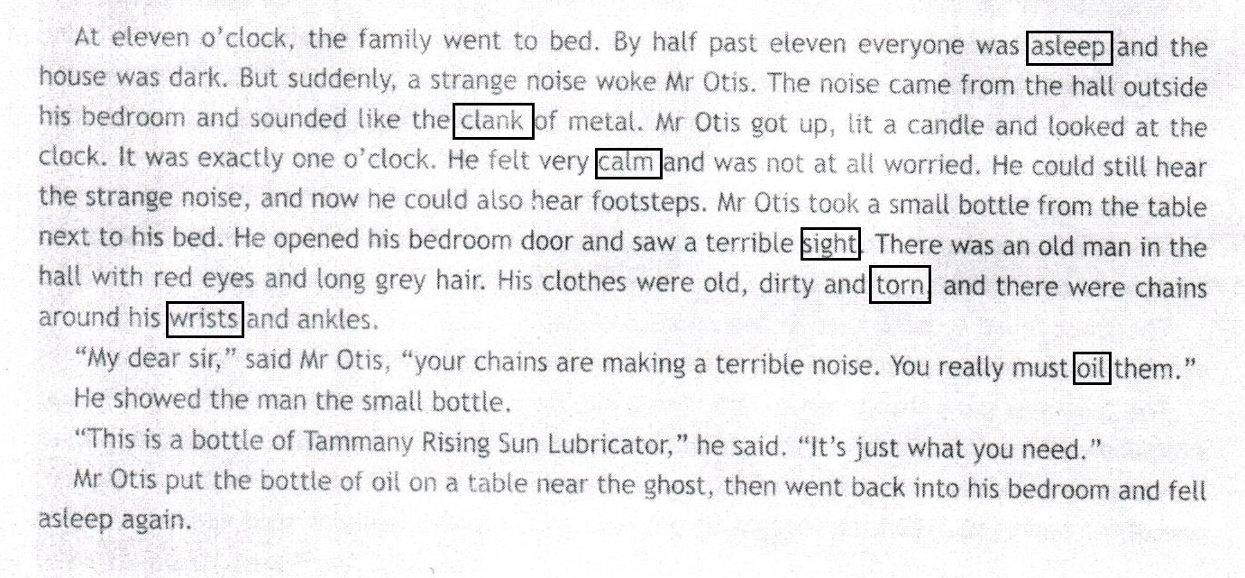

3. Выразительное чтение
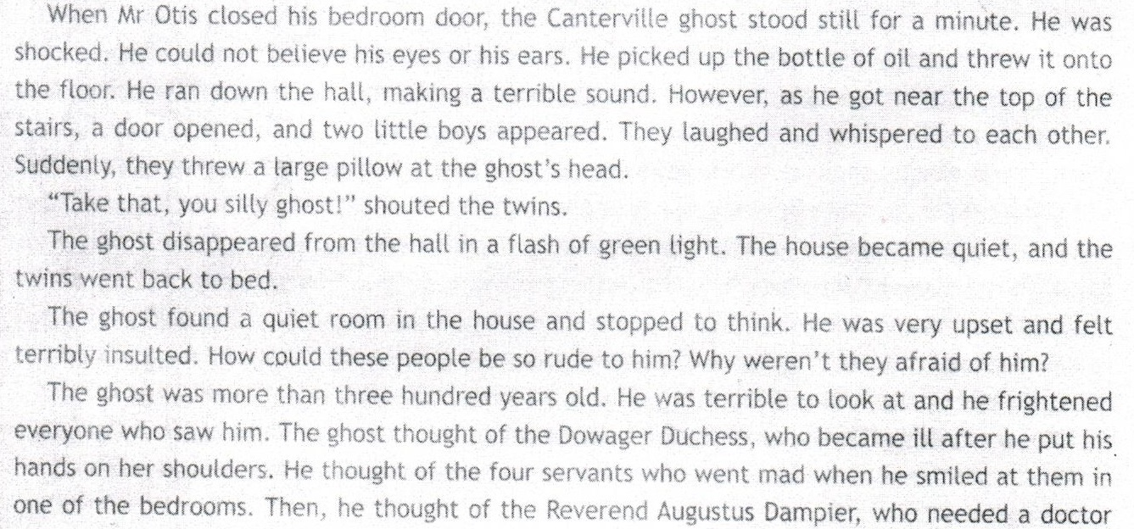
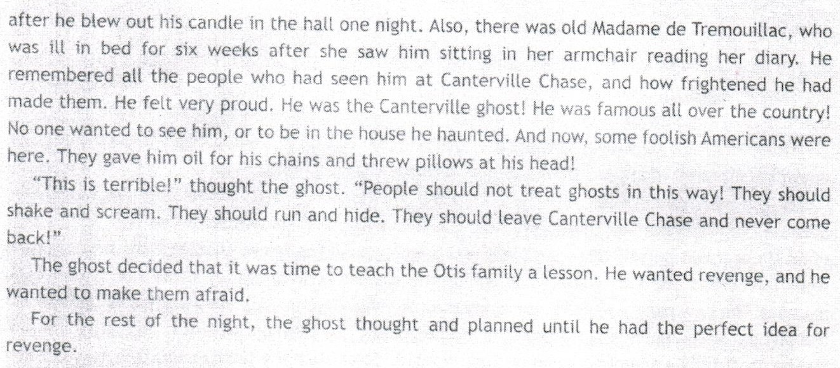
Прочитай текст и отметь «Правда или Ложь»
- The Ghost picked up the bottle of perfume and threw it onto the floor. F
- There were twins on the top of the stairs. T
- People in this house weren’t afraid of the ghost. T
- The ghost was more than five hundred years ago. F
- The Dowager Duchess went mad after the ghost put his hands on her shoulders. F
- The ghost was very proud of the new hosts of the house. F
- In the ghost’s opinion, people should shake and scream when they saw him. T
- The Canterville Ghost wanted revenge. T
- He didn’t have any idea last night. F

