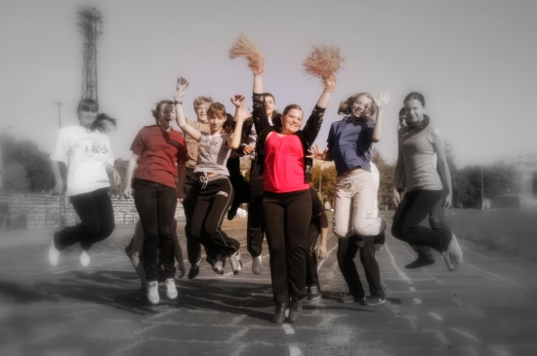
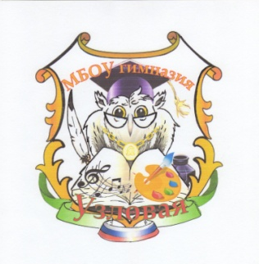
To British schoolchildren
From the pupils of 8th B form

Municipal Gymnasium
town of Uzlovaya
Tula region

6 September, 2017

Dear boys and girls,
We, the pupils of 8th B form, would make friends with the students from one of the schools in the United Kingdom of Great Britain. Thanks to the World Festival of the Youth and Students which is held in Russia a great idea was born – to write letters to contemporaries in other countries for communication and doing together different useful things. We liked this idea very much. We’d like to communicate with boys and girls the same age. There are a lot of twin-cities. Why not to have twin- school or twin-class!

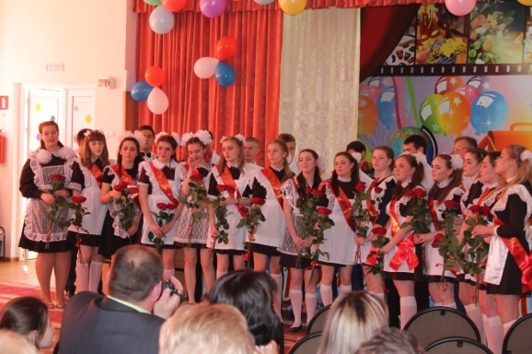
We are 14, some of us are 15. We live in the small town of Uzlovaya in Tula region. It’s not far from Moscow. More than 400 pupils study in our school. We learn Maths, Physics, Chemistry, Social History, Biology, PT with great pleasure. The children study English from the second form. We can speak to you without an interpreter.

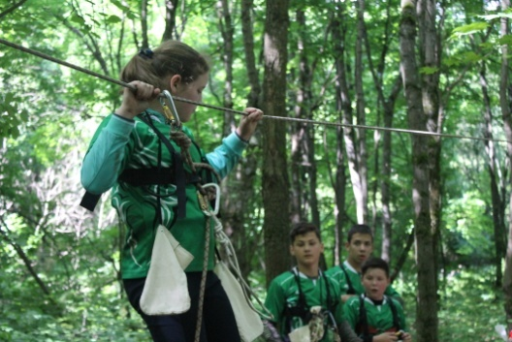
Our class leader Marina Igorevna Averkova teaches us History not only of Russia, but of other countries. We go in for sport, take part in different competitions and tourist meetings, do different projects. We are fond of films, books, music, computer games.
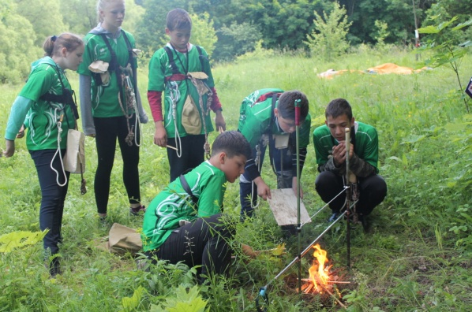

It is very interesting to find friends holding the same views in your country. What is your hobby? What subjects do you study in school? What are you interested in? Do you like sport? We hope there are a lot of themes for our communication. We can speak to you in Skype.

We will be happy to receive a letter. We are sure the children all over the world are our good friends.
In our letter you can find photos about our school and school life.
Our e-mail gymnasiumuzl13@mail.ru
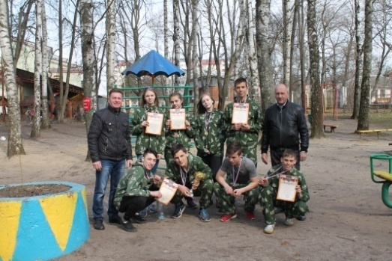
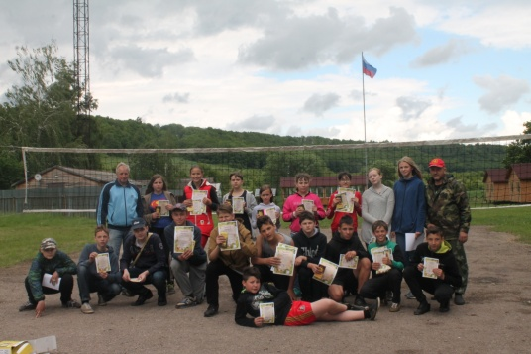

Best wishes,
pupils of 8th B form

